Pagemark 0.13.1 Android mobile audit
Version 0.13.1
Commit e42cc26
2026-10-14
Revision 1.3

Mobile Application Release Audit - Pagemark (Android)
Version 0.13.1 (2022), commit e42cc26 = tag v0.13.1. Platform: Android only (iOS out of scope, scaffolding). Environment: production candidate.
Artifacts: Pagemark-0.13.1-arm64.apk sha256 3a0f7e78...351be9; armv7.apk f5151fdc...ded0b4; play.aab fd5ee9b5...016b0734.
Evidence mode: artifact + static + runtime smoke on one Android 17 x86_64 emulator (arm64 APK, ABI-translated) + unit/widget suite. No real phone. Identity gate: PASS. Audited 2026-10-14. Store policy checked 2026-10-14: developer.android.com/google/play/requirements/target-sdk (page dated 2026-10-01). MASVS: control groups used by name; IDs not cited.

DECISION
- GitHub sideload APKs: CONDITIONAL GO. No blocker, no S3+ finding.
- Google Play upload: CONDITIONAL NO-GO until the Data safety form is checked (MOB-PRV-0002) and a real-device pass is done.
Coverage: ~24 controls tested (PASS/PASS-WARN), 0 FAIL; NOT TESTED or MANUAL REVIEW: fresh install/removal, navigation/state, TalkBack, device matrix, clipboard/recents, real-phone performance, Data safety. See coverage.md.
Scores (coverage): Security 99 (~70%), Privacy 98 (~50%), Store 97 (~40%), Reliability 100 (~30%), UX/Perf not scored (emulator only).
Counts after fixes: blockers 0, S4 0, S3 0, open S2 1, open S1 1, fixed 3, S0 1 (accepted). Fixes are uncommitted and ship with the next versioned build (the signing change only affects new builds).

Findings
- MOB-PRV-0002 S2 (store) OPEN: Data safety draft now covers ML Kit diagnostics; scanner traffic capture on a real phone still needed
- MOB-PRV-0001 S1 FIXED-VERIFIED: privacy policy permission list and Drive wording
- MOB-BLD-0003 S1 FIXED-VERIFIED: v2+v3 signing enabled
- MOB-AND-0004 S1 FIXED-VERIFIED: end-of-life sqlite3_flutter_libs removed
- MOB-STORE-0005 S1 OPEN (owner): PLAY_STORE.md refreshed; 1024x500 feature graphic still to make
- MOB-SEC-0006 S0 locked DB unencrypted - owner-accepted

Passed highlights
Not debuggable; backup and device-transfer off; no cleartext or custom TLS; https hosts only; Play AAB has no install permission; target 36 and 16 KB alignment OK; same signing cert on both APKs; PIN PBKDF2 150k + salt + lockout; backup AES-256-GCM; analyze clean; 295 tests pass. Runtime: 0 crashes/ANRs, upgrade keeps data, offline launch and 2.0 text scale render cleanly, 0 OSV vulnerabilities in 187 packages.

Missing for a full GO
Device pass (MANUAL_TEST_PLAN.md: timer, folder backup to cloud, fingerprint, notifications, TalkBack, updater, upgrade from 0.13.0), logcat/clipboard/recents check, scanner traffic capture, real-phone performance numbers, and verification that the 0.13.1 fixes for PGM-300/302/320 work on a device.
Details: findings/*.md, coverage.md, artifact/.

MOB-AND-0004 - Dependency sqlite3_flutter_libs is on its "+eol" release; OSV scan found no known CVEs
Severity S1 | Status fixed-verified | Confidence medium | Basis static | Blockers []
The package version string marks end of life; the bundled libsqlite3.so will not receive upstream updates through it. OSV batch query of all 187 locked pub packages returned no vulnerabilities (artifact/sbom-pub.txt); the concern is maintenance only. Remediation: move to the maintained sqlite3 native-assets path (sqlite3 ^3.x is already a dependency) and rerun the scan. Verify: pubspec has no +eol package and the OSV scan is clean.
Fix (2026-10-14): sqlite3_flutter_libs removed from pubspec.yaml; the sqlite3 package bundles SQLite itself. flutter analyze clean, 295 tests pass, release APK still contains libsqlite3.so, and on the emulator the app opened the existing database (library intact), 0 fatal errors, cold start 613-729 ms (native x86_64).

MOB-BLD-0003 - Release APK signed with APK Signature Scheme v2 only (no v3/rotation lineage)
Severity S1 | Status fixed-verified | Confidence high | Basis artifact | Blockers []
apksigner: v1 false, v2 true, v3 false. Valid for minSdk 24. Without v3 a compromised or lost key cannot be rotated for sideload users, and CLAUDE.md already warns that losing the key blocks in-place upgrades. Play App Signing covers the Play build, not the GitHub APKs.
Remediation: keep the keystore backed up (NAS script exists); optionally sign with v3 so a rotation lineage can be added later. Verify: apksigner verify shows v3 true.
Fix (2026-10-14): android/app/build.gradle.kts release signing now sets enableV1Signing=false, enableV2Signing=true, enableV3Signing=true. A signed release build verified v2 true and v3 true with the same certificate SHA-256 (26b4a423...). Takes effect on the next versioned release build.

MOB-PRV-0001 - Privacy policy permission list and Drive wording do not match the shipped manifest
Severity S1 | Status fixed-verified | Confidence high | Basis artifact | Blockers []
Merged manifest also holds VIBRATE, WAKE_LOCK, RECEIVE_BOOT_COMPLETED, FOREGROUND_SERVICE, USE_FINGERPRINT (from plugins/WorkManager/notifications); the policy lists none of them. The Locked-library paragraph still says exports include "Drive backups", but Drive backup was removed in 0.8.2.
Remediation: list the extra permissions with one-line reasons (or strip unused ones with tools:node="remove" if confirmed unused, e.g. FOREGROUND_SERVICE), replace "Drive backups" with "folder backups". Verify: aapt2 dump badging vs the policy list.
Fix (2026-10-14): docs/PRIVACY.md now lists WAKE_LOCK, RECEIVE_BOOT_COMPLETED, FOREGROUND_SERVICE, VIBRATE and USE_FINGERPRINT with reasons and says folder backups instead of Drive; verified against the merged manifest list. The permissions themselves were kept (WorkManager and notifications use them).

MOB-PRV-0002 - Play Data safety draft does not address ML Kit barcode scanner telemetry
Severity S2 | Status open | Confidence medium | Basis static | Blockers [store]
PRIVACY.md admits Google's ML Kit "may report anonymous technical information to Google", yet the Data safety answers say nothing is collected except lookups. Google can flag a form that omits SDK collection. Unverified at runtime (no traffic capture), so MANUAL REVIEW.
Remediation: capture the scanner's network traffic once on a device, then declare diagnostics/device identifiers accordingly (or confirm none), and align both documents. Verify: traffic log + Play Console form.
Fix (2026-10-14): docs/PLAY_STORE.md Data safety answers now state that the ML Kit reader may send diagnostics and give the exact rule for declaring Diagnostics after a traffic capture. The capture on a real phone is still needed before the form is submitted.

MOB-SEC-0006 - Locked library is not encrypted at rest (owner decision)
Severity S0 | Status accepted-risk | Confidence high | Basis static | Blockers []
The PIN gates the UI; the SQLite file is plain inside app-private storage (backup, adb and cloud transfer disabled). Owner declined SQLCipher on 2026-10-12; recorded, not re-proposed. Exposure needs a rooted device or forensic access; the encrypted backup option covers exported copies.

MOB-STORE-0005 - PLAY_STORE.md open items are stale (refers to 0.7.1) and the feature graphic is still missing
Severity S1 | Status open | Confidence high | Basis static | Blockers []
Checklist still says verify 0.7.1 fixes and regenerate screenshots; 1024x500 graphic not made. Remediation: refresh the checklist for 0.13.x/1.0.0 and create the graphic. Verify: all listing assets present in Play Console.
Fix (2026-10-14): docs/PLAY_STORE.md checklist refreshed for the current release (real-phone pass, scanner traffic capture, screenshots, pre-launch report). Still open and owner-only: create the 1024x500 feature graphic.

Coverage - Pagemark 0.13.1+22, Android (sideload arm64 APK + play AAB), evidence mode: artifact + static + runtime smoke on Android 17 x86_64 emulator (arm64 APK, ABI-translated) + test suite
Method tags: [artifact] [static] [runtime-suite] (unit/widget tests only, no device).
Control | State | Evidence
01 identity: pkg com.axialforge.pagemark, 0.13.1 (2022), target/compile 36, min 24, arm64 | PASS [artifact] | artifact/badging.txt
01 identity gate: tag v0.13.1 == HEAD e42cc26, tree clean, APK built after commit | PASS [static] | git rev-parse
02 not debuggable, no debuggable attr | PASS [artifact] | merged-manifest.txt
02 signing release key (CN=Pagemark), same cert on arm64+armv7, key.properties gitignored | PASS [artifact] fixed: v2+v3 signing verified 2026-10-14 (MOB-BLD-0003) | signing.txt
02 R8 mapping present; no secrets/staging URLs found (hits are license/library strings) | PASS-WARN [artifact] | secret-smells.txt
02 16 KB page alignment of .so | PASS [artifact] | zipalign -P 16 OK
02 play AAB lacks REQUEST_INSTALL_PACKAGES | PASS [artifact] | AAB manifest grep
03 upgrade: 0.13.1 installed over existing emulator install, data kept (library shows Dune) | PASS [runtime] | rt-launch.png, rt-package.txt
03 fresh install, removal/reinstall, upgrade from a published release | NOT TESTED; migrations covered by suite [runtime-suite] | test.txt
05/08 text scale 2.0 on Library: no overflow or clipping | PASS [runtime] | rt-font2.png
11/20 launch in airplane mode, no crash; process kill then relaunch restores app | PASS [runtime] | rt-offline.png, logcat 0 fatal
07 back/rotation/state restore, deep paths | NOT TESTED
04,06,08 (TalkBack),09 (device matrix: one emulator only) | NOT TESTED / MANUAL REVIEW (MANUAL_TEST_PLAN.md)
10 performance: cold start 2.8-4.4 s, PSS 231 MB (emulator, ABI translation, not representative) | PASS-WARN [runtime] MANUAL REVIEW on real phone | rt-perf.txt
12 local storage: allowBackup=false, extraction rules exclude all | PASS [artifact] | merged-manifest.txt
12 locked DB unencrypted | accepted-risk MOB-SEC-0006
12/15 PIN PBKDF2-SHA256 150k, random 16B salt, attempt limiting, const-time compare; backup AES-256-GCM | PASS-WARN [static] | lib/lock.dart, crypto_backup.dart
12 logcat: 0 fatal/ANR, no PIN/title/token content from the app; run-as refused (not debuggable) | PASS [runtime] | rt-logcat.txt
12 clipboard, recents thumbnail (FLAG_SECURE on lock) | NOT TESTED (static only)
13 network: only https hosts, no cleartext config, no custom TrustManager | PASS [static] | grep lib
14 backend | N/A (no backend, no accounts) | CLAUDE.md, lib grep
15 accounts / account deletion | N/A (no accounts)
17 permissions (runtime-granted set matches manifest; Android 17 auto-grants ACCESS_LOCAL_NETWORK to this older target, not declared) : INTERNET, CAMERA, BIOMETRIC, POST_NOTIFICATIONS justified; extras | PASS fixed in docs/PRIVACY.md (MOB-PRV-0001) | badging.txt
PLATFORM exported components: MainActivity (MAIN+SEND text, whitelisted), others permission-guarded or unexported | PASS-WARN [artifact] (untrusted-intent handling static only) | merged-manifest.txt
18 deps: 187 pub packages, OSV query: 0 known vulnerabilities; SBOM list; sqlite3_flutter_libs +eol | PASS [artifact] fixed: sqlite3_flutter_libs removed, OSV clean (MOB-AND-0004) | sbom-pub.txt
19 tamper/resilience | N/A for threat model (local hobby app)
21 telemetry: none declared; no analytics SDK | PASS [static] | pubspec.yaml
22 target API 36 meets Play rule (new apps/updates need 36 from 2026-08-31; page dated 2026-10-01) | PASS [artifact] | developer.android.com/google/play/requirements/target-sdk
22 Data safety, content rating, declarations | MANUAL REVIEW MOB-PRV-0002
23 listing claims vs behaviour | PASS-WARN [static] MOB-STORE-0005 | PLAY_STORE.md
Suite: flutter analyze clean; flutter test 295 pass, 1 skip | PASS [runtime-suite] | analyze.txt, test.txt

| Fix verification 2026-10-14: signed release rebuilt, v2+v3 verified; analyze clean; 295 tests pass; x86_64 release on emulator opens existing DB, 0 fatal, cold start 613-729 ms | PASS [runtime] | rt-fix-startup.txt, rt-fix-launch.png |

Appendix A - Scope, method and evidence index

Scope and environment
- App: Pagemark, com.axialforge.pagemark, version 0.13.1 (versionCode 2022), commit e42cc26 = tag v0.13.1, clean working tree.
- Platform: Android only. The iOS folder is scaffolding (needs a Mac) and is out of scope.
- Flavors: sideload (GitHub APK, self-updates, has REQUEST_INSTALL_PACKAGES) and play (AAB, no installer permission). Both audited from the build artifacts.
- Threat model: local-only personal app, no accounts, no backend. Data classes: reading log (user content), optional PIN-gated "locked library", backup files. Attackers considered: lost or stolen device, co-resident malicious app, network observer, malicious share intent. Reverse engineering and tamper resistance are out of profile (MASVS-RESILIENCE not required).
- Evidence modes used: artifact inspection, source review, unit and widget suite, and a runtime smoke on one Android 17 x86_64 emulator. The arm64 APK ran through ABI translation, so timings are not representative. No real phone was used.
- Tools: aapt2 and apksigner (build-tools 36.0.0), zipalign (16 KB check), adb, flutter analyze and flutter test, OSV batch query (api.osv.dev) for dependencies.
- OWASP MASVS control groups are named by group only. No MASWE or MASTG IDs are cited because they were not looked up at audit time.

Artifacts audited
File | Size (bytes) | SHA-256
Pagemark-0.13.1-arm64.apk | 32,947,434 | 3a0f7e78b6081018119ed667206f453b4ed68f0dd8b41c3a5d93f6fcf0351be9
Pagemark-0.13.1-armv7.apk | 29,161,302 | f5151fdca3c9f003cc13f85d93cc89c46ddc9ec8f7c7f2e07f9eeece40ded0b4
Pagemark-0.13.1-play.aab | 80,344,732 | fd5ee9b589106beeae3599b85deb96e3a1b79c541b315900b6aca14e016b0734

Identity gate (PASS)
- Git: tag v0.13.1 resolves to HEAD e42cc2674f928e8f0063a910ef9332daff532825; git status clean; release files were written after the commit (19:02 vs 18:59).
- Manifest: package, versionName 0.13.1, versionCode 2022, compile and target SDK 36, minSdk 24, native code arm64-v8a (arm64 APK).
- Signing: one signer, CN=Pagemark, O=AxialForge, RSA 2048, certificate SHA-256 26b4a4234bc4346eb7e63ebee49c114cbdadd1fa10e60a5cc34f324d6b1bac44, identical on arm64 and armv7. Scheme: v2 only (see MOB-BLD-0003). The keystore and key.properties are not tracked by git.

Store policy sources checked
- Google Play target API requirement, https://developer.android.com/google/play/requirements/target-sdk, fetched 2026-10-14 (page last updated 2026-10-01): new apps and updates must target API 36 from 2026-08-31; Pagemark targets 36.
- Apple checks: not applicable (Android only).
- Data safety, content rating and account-deletion policies were not fetched; those controls are MANUAL REVIEW.

Evidence files (folder artifact/)
badging.txt, merged-manifest.txt, signing.txt, sha256.txt, file-list.txt, secret-smells.txt, manifest-flags.txt, analyze.txt, test.txt, sbom-pub.txt, rt-perf.txt, rt-logcat.txt, rt-launch.png, rt-offline.png, rt-font2.png.

Automated results
- flutter analyze: No issues found.
- flutter test: 295 passed, 1 skipped, 0 failed.
- Secret smell scan of the unpacked APK: 200 hits, all reviewed as license URLs, XML namespaces and strings inside libflutter, libapp and classes.dex (words such as "password" and "staging"). No keys, tokens, private-key blocks or .env content found. Values were redacted by the script.
- 16 KB page alignment: zipalign -c -P 16 reports OK for every native library checked in the arm64 APK.
- Play AAB manifest: no REQUEST_INSTALL_PACKAGES, not debuggable.
- Runtime on emulator: 0 fatal exceptions or ANRs in 4,881 logcat lines; process kill then relaunch recovers; airplane-mode launch works; Library at 2.0 font scale renders without overflow.

Appendix B - Inventories

B1. Permissions (merged manifest, sideload arm64)
Permission | Source | Needed for | Runtime prompt | Verdict
INTERNET | app | book lookup, covers, update check | no | justified
CAMERA | app | barcode scanner | yes, on first scan | justified
USE_BIOMETRIC | app | fingerprint unlock | no | justified
USE_FINGERPRINT | local_auth (legacy) | same, older Android | no | justified, missing from policy
POST_NOTIFICATIONS | app | reminders and backup-problem notice | yes (Android 13+) | justified
REQUEST_INSTALL_PACKAGES | sideload flavor only | install a downloaded update | special access | justified, absent from Play build
ACCESS_NETWORK_STATE | plugin | backup and lookup network checks | no | justified
WAKE_LOCK | WorkManager | scheduled work | no | missing from policy
RECEIVE_BOOT_COMPLETED | WorkManager / notifications | re-schedule reminders after reboot | no | missing from policy
FOREGROUND_SERVICE | WorkManager | long background work | no | confirm needed; missing from policy
VIBRATE | notifications | notification vibration | no | missing from policy
com.axialforge.pagemark.DYNAMIC_RECEIVER_NOT_EXPORTED_PERMISSION | AndroidX | internal receiver protection | no | normal

Removed on purpose with tools:node="remove": READ_EXTERNAL_STORAGE, READ_MEDIA_IMAGES, READ_MEDIA_VIDEO, READ_MEDIA_AUDIO. Not present: location, contacts, microphone, SMS, storage, accounts, advertising ID. On the Android 17 emulator the system also showed ACCESS_LOCAL_NETWORK as granted automatically for this older target SDK; the app does not declare it.

B2. Application components
Component | Exported | Guard | Notes
MainActivity | yes | none needed | MAIN/LAUNCHER and a SEND text/plain share target; shared text is capped, whitelisted and only pre-fills the search box
PagemarkWidgetProvider (receiver) | no |  | home-screen widget, main library only
androidx.glance GlanceRemoteViewsService | yes | BIND_REMOTEVIEWS | system-only binding
WorkManager SystemJobService | yes | BIND_JOB_SERVICE | system-only binding
WorkManager DiagnosticsReceiver, profileinstaller ProfileInstallReceiver | yes | DUMP | system and shell only
ML Kit, content providers and other library components | no

Application flags: allowBackup=false, fullBackupContent=false, dataExtractionRules exclude root, file, database, sharedpref and external for both cloud backup and device transfer, not debuggable, extractNativeLibs=false.

B3. Network endpoints (all HTTPS, from source)
Host | Purpose | Trigger | Data sent
openlibrary.org, covers.openlibrary.org | search, ISBN lookup, covers | user search or scan, cover display | query text or ISBN, IP address
www.googleapis.com (Google Books) | second lookup source, can be switched off | user search | query text
api.github.com, github.com | update check and APK download (sideload flavor) | at most daily, switchable | public release request only

No cleartext configuration, no custom TrustManager or HostnameVerifier, no certificate pinning (not needed for public book data). A test in the repository enforces the host allow-list (promiseHosts).

B4. Data-flow inventory
Data | Where stored | Encrypted at rest | Leaves device? | Recipient | Deletion
Books, reads, ratings, thoughts, quotes, shelves | SQLite in app-private storage | no (owner-accepted, MOB-SEC-0006) | only through exports and backups the user saves | user-chosen location | uninstall, or in-app delete and Trash
Locked library | same database, locked flag | no | in the full-database backup only, optionally AES-256-GCM encrypted | user-chosen location | in-app
PIN hash, salt, recovery hash | flutter_secure_storage (Keystore backed) | yes | no |  | clear lock, or uninstall
Backup passphrase | flutter_secure_storage | yes | no |  | uninstall
Settings, filters, timer state | SharedPreferences | no (non-sensitive) | no |  | uninstall
Event log (200 KB cap, SQL details scrubbed) | app files | no | only if the user shares a problem report | user | in-app
Cover images | cache and local: cover store; locked covers in a separate cache wiped on lock | no | no |  | in-app
Search text and ISBN | memory | n/a | yes, to the lookup hosts above | Open Library, Google Books | not retained by the app
Camera frames | memory only | n/a | not stored or sent by the app; the ML Kit library may report technical data (MOB-PRV-0002)

Accounts, advertising IDs, analytics, crash reporting, location and contacts: none. Account deletion requirements: not applicable (no accounts).

B5. Cryptography and local security
Item | Finding
PIN | PBKDF2-HMAC-SHA256, 150,000 iterations, random 16-byte salt per install, constant-time compare, attempt limiting with lockout up to 1 hour (clock-skew capped), recovery code stored as a hash; legacy SHA-256 PIN upgraded on use
Backup encryption | "PGMKENC1": AES-256-GCM, 16-byte random salt, 12-byte nonce, key from PBKDF2-SHA256 at 150,000 iterations
Secrets in source | none found; signing config reads an untracked key.properties
Screen capture | FLAG_SECURE while the locked library is open; the vault relocks on pause (static review; recents thumbnail not verified at runtime)
Locked-library leaks | exports, stats, widget and suggestions filter on locked; covered by repository tests

B6. Dependencies (pub.dev, from pubspec.lock)
187 packages. OSV result: no known vulnerabilities.
Direct packages of note: drift 2.35.2, sqlite3 3.7.0, (sqlite3_flutter_libs 0.6.0+eol was removed 2026-10-14, MOB-AND-0004; the list below is the pre-fix SBOM and still shows it), http 1.6.0, local_auth 3.0.2, flutter_secure_storage 11.2.0, cryptography 2.9.0, mobile_scanner 7.4.2 (Google ML Kit), home_widget 0.10.0, flutter_local_notifications 22.3.2, file_picker 13.1.0, share_plus 13.3.1, open_filex 4.7.0, image_picker 1.2.4, pdf 3.13.1, archive 4.5.1, cached_network_image 4.0.4, package_info_plus 10.2.2, device_info_plus 13.3.0, android_intent_plus 6.1.0. No analytics, advertising, crash-reporting or payment SDK.
Native libraries in the arm64 APK: libflutter, libapp, libsqlite3, libbarhopper_v3 (ML Kit barcode), libdartjni, libimage_processing_util_jni, libsurface_util_jni, libdatastore_shared_counter.

Full package list (SBOM)
Package | Version
_fe_analyzer_shared | 109.0.0
analyzer | 14.5.0
android_file_picker | 2.0.1
android_intent_plus | 6.1.0
archive | 4.5.1
args | 2.7.0
async | 2.13.1
barcode | 2.2.9
bidi | 2.0.13
boolean_selector | 2.1.2
build | 4.0.11
build_config | 1.3.3
build_daemon | 4.1.6
build_runner | 2.16.2
built_collection | 5.1.2
built_value | 8.13.0
cached_network_image | 4.0.4
cached_network_image_platform_interface | 5.0.3
cached_network_image_web | 2.0.3
characters | 1.4.1
charcode | 1.4.0
checked_yaml | 2.0.4
cli_util | 0.6.0
clock | 1.1.3
code_assets | 2.1.0
collection | 1.19.1
convert | 3.1.2
cross_file | 0.3.5+5
crypto | 3.0.7
cryptography | 2.9.0
cryptography_flutter | 2.3.4
csv | 8.0.0
cupertino_icons | 1.0.9
cupertino_ui | 1.1.2
dart_style | 3.1.13
dbus | 0.8.0
device_info_plus | 13.3.0
device_info_plus_platform_interface | 8.1.0
drift | 2.35.2
drift_dev | 2.35.1
fake_async | 1.3.3
ffi | 2.2.0
ffi_leak_tracker | 0.1.2
file | 7.0.1
file_picker | 13.1.0
file_picker_darwin | 2.2.0
file_picker_linux | 2.0.2
file_picker_platform_interface | 4.1.0
file_picker_web | 4.1.0
file_selector_linux | 0.9.4+1
file_selector_macos | 0.9.5+1
file_selector_platform_interface | 2.7.0
file_selector_windows | 0.9.3+6
fixnum | 1.1.1
flutter | 0.0.0
flutter_cache_manager | 3.4.5
flutter_lints | 6.0.0
flutter_local_notifications | 22.3.2
flutter_local_notifications_linux | 8.0.2
flutter_local_notifications_platform_interface | 12.2.0
flutter_local_notifications_web | 1.0.0
flutter_local_notifications_windows | 3.1.1
flutter_localizations | 0.0.0
flutter_plugin_android_lifecycle | 2.0.35
flutter_secure_storage | 11.2.0
flutter_secure_storage_darwin | 0.4.3
flutter_secure_storage_linux | 3.0.3
flutter_secure_storage_platform_interface | 2.1.1
flutter_secure_storage_web | 2.1.1
flutter_secure_storage_windows | 4.2.2
flutter_test | 0.0.0
flutter_web_plugins | 0.0.0
glob | 2.2.0
graphs | 2.3.2
home_widget | 0.10.0
hooks | 2.2.0
http | 1.6.0
http_multi_server | 3.2.2
http_parser | 4.1.2
image | 4.12.0
image_picker | 1.2.4
image_picker_android | 0.8.13+25
image_picker_for_web | 3.1.1
image_picker_ios | 0.8.13+10
image_picker_linux | 0.2.2
image_picker_macos | 0.2.2+1
image_picker_platform_interface | 2.11.2
image_picker_windows | 0.2.2
intl | 0.20.3
io | 1.1.0
jni | 1.1.0
jni_flutter | 1.0.4+1
jni_util | 1.0.0
json_annotation | 4.12.0
leak_tracker | 11.0.2
leak_tracker_flutter_testing | 3.0.10
leak_tracker_testing | 3.0.2
lints | 6.1.0
local_auth | 3.0.2
local_auth_android | 2.2.0
local_auth_darwin | 2.0.4
local_auth_platform_interface | 1.1.0
local_auth_windows | 2.0.2
logging | 1.3.0
matcher | 0.12.20
material_color_utilities | 0.13.0
material_ui | 1.6.0
meta | 1.19.0
mime | 2.1.0
mobile_scanner | 7.4.2
native_toolchain_c | 0.19.5
objective_c | 9.6.2
octo_image | 2.1.2
open_filex | 4.7.0
package_config | 3.0.0
package_info_plus | 10.2.2
package_info_plus_platform_interface | 4.1.0
path | 1.9.1
path_parsing | 1.1.0
path_provider | 2.1.6
path_provider_android | 2.3.1
path_provider_foundation | 2.6.0
path_provider_linux | 2.2.2
path_provider_platform_interface | 2.1.3
path_provider_windows | 2.3.0
pdf | 3.13.1
petitparser | 7.1.0
platform | 3.2.0
plugin_platform_interface | 2.1.8
pool | 1.5.3
posix | 6.5.2
process | 5.0.6
pub_semver | 2.2.1
pubspec_parse | 1.6.0
qr | 3.0.2
recase | 4.1.0
record_use | 1.1.1
rxdart | 0.28.0
share_plus | 13.3.1
share_plus_platform_interface | 7.2.0
shared_preferences | 2.5.6
shared_preferences_android | 2.4.28
shared_preferences_foundation | 2.5.7
shared_preferences_linux | 2.4.1
shared_preferences_platform_interface | 2.4.2
shared_preferences_web | 2.4.3
shared_preferences_windows | 2.4.1
shelf | 1.4.2
shelf_web_socket | 3.0.0
sky_engine | 0.0.0
source_gen | 4.3.0
source_span | 1.10.2
sqflite | 2.4.4+1
sqflite_android | 2.4.4
sqflite_common | 2.5.13+1
sqflite_darwin | 2.4.4
sqflite_platform_interface | 2.4.2
sqlite3 | 3.7.0
sqlite3_flutter_libs | 0.6.0+eol
sqlparser | 0.45.0
stack_trace | 1.12.2
stream_channel | 2.1.4
stream_transform | 2.1.2
string_scanner | 1.4.1
synchronized | 3.4.2
term_glyph | 1.2.2
test_api | 0.7.12
timezone | 0.11.2
typed_data | 1.4.0
url_launcher_linux | 3.2.3
url_launcher_platform_interface | 2.3.2
url_launcher_web | 2.4.3
url_launcher_windows | 3.1.6
uuid | 4.6.0
vector_math | 2.4.3
vm_service | 15.3.0
watcher | 1.2.1
web | 1.1.1
web_socket | 1.0.1
web_socket_channel | 3.0.3
win32 | 6.4.0
win32_registry | 3.0.3
windows_file_picker | 2.0.1
xdg_directories | 1.1.0
xml | 7.1.0
yaml | 3.1.4
yaml_edit | 2.2.4

Appendix C - Store disclosure, device matrix and open items

C1. Store disclosure diff (Google Play Data safety)
Data type | Declared in docs/PLAY_STORE.md | Observed | Match
Search queries, app activity | sent to Open Library and Google Books, optional, not linked to identity | confirmed in source (lookup.dart) | yes
Personal info, financial, health, location, contacts, messages, photos, audio | none | none found in the manifest or source | yes
Camera images | processed on device, not stored or sent | the app never stores or sends them; the ML Kit library may report technical info to Google per the privacy policy | UNVERIFIED (MOB-PRV-0002)
Device or other IDs, diagnostics | none | not verified at runtime for the ML Kit component | UNVERIFIED
Encryption in transit | HTTPS | all hosts HTTPS, no cleartext | yes
Deletion | clear storage, delete backups | no accounts; uninstall removes app data | yes
Permissions in the privacy policy | internet, camera, biometric, install packages, notifications, background work and network state | five more in the merged manifest | NO (MOB-PRV-0001)
Listing claims "no account, no ads, no tracking, no AI, never collects your data" |  | no accounts, ads, analytics or AI SDKs found; lookups expose search text and IP to third parties, which the policy discloses | yes, with the ML Kit caveat

C2. Play checklist status
Item | State
Target API meets the requirement (36) | PASS
64-bit and AAB | PASS (arm64 and armv7 APKs, AAB built)
16 KB page alignment | PASS
Installer permission absent from the Play flavor | PASS
Data safety form | MANUAL REVIEW
Privacy policy URL (public GitHub page) | present; content needs the MOB-PRV-0001 fix
Content rating and target audience (13+) | MANUAL REVIEW (answers drafted)
Account deletion | N/A, no accounts
Ads declaration | none
Restricted-permission declarations | none needed (no SMS, call log, background location, all-files access)
Feature graphic 1024x500 and current screenshots | OPEN (MOB-STORE-0005)
Pre-launch report | NOT RUN (needs Play Console); the test robot cannot pass a PIN lock

C3. Device and OS matrix actually exercised
Cell | Exercised
Pixel_10_Pro_XL_test emulator, Android 17, x86_64 with arm64 translation, 1344x2992 | yes: install-over, launch, offline, 2.0 font scale, process kill
Real phone (any) | NO
Low-end device, Samsung, tablet or foldable | NO (a tablet two-pane layout was exercised in the earlier 1.0.0 gate audit, emulator only)
Min SDK 24 device | NO
Android 13 notification prompt, biometric hardware, camera hardware | NO

C4. Manual review queue
- Capture the barcode scanner's network traffic once on a device, then fix or confirm the Data safety form (MOB-PRV-0002).
- Update PRIVACY.md (permission list and Drive wording) and decide whether FOREGROUND_SERVICE can be stripped (MOB-PRV-0001).
- Real-phone pass from docs/release-audit/MANUAL_TEST_PLAN.md: reading timer, folder backup to a real cloud folder, fingerprint, notifications on Android 13+, camera scan, share sheet, widget, TalkBack, in-app updater install, upgrade from the published 0.13.0 APK.
- Check the recents-screen thumbnail and clipboard behavior with the locked library open.
- Fresh install, uninstall and reinstall, and what survives (keystore data, backup folder).
- Confirm on a device that the 0.13.1 fixes for PGM-300 (Stats width), PGM-302 (genre noise) and PGM-320 (stuck timer) work; they are marked ready for verification in the repository audit.
- Real-phone performance: cold start and scrolling a large library (the earlier 5,000-book test was emulator only).
- Create the Play listing assets and run Play's pre-launch report.

C5. What is missing for a clean GO
Items 1, 2 and 3 above. With those closed and no new S2 or higher findings, the Play decision moves to GO; the sideload APKs are already a conditional go.

Appendix D - Runtime evidence
Emulator: Pixel_10_Pro_XL_test, Android 17, x86_64. Pagemark 0.13.1 (2022) was installed over an existing install with the same signing key; the library kept its data.
Measure | Result
Cold start (am start -W TotalTime), 3 runs | 4,409 ms, 3,021 ms, 2,795 ms (ABI translation inflates this)
Offline launch (airplane mode) | 3,086 ms, app opened normally
Memory after launch | TOTAL PSS 230,927 KB, RSS 376,772 KB, Java heap 5.6 MB, native heap 27.5 MB
First-frame render | 1 frame, 23 ms (not a useful jank measure)
Fatal exceptions or ANRs in logcat | 0 of 4,881 lines; only SELinux max_map_count notices and a CPU-variant warning from the emulator
Debugger access to private data | run-as refused: package not debuggable
Kill and relaunch | process restarted, no crash

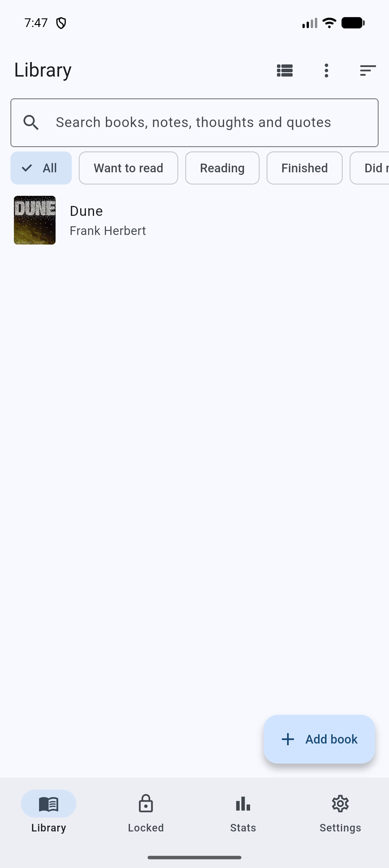
Library on launch (default text size)
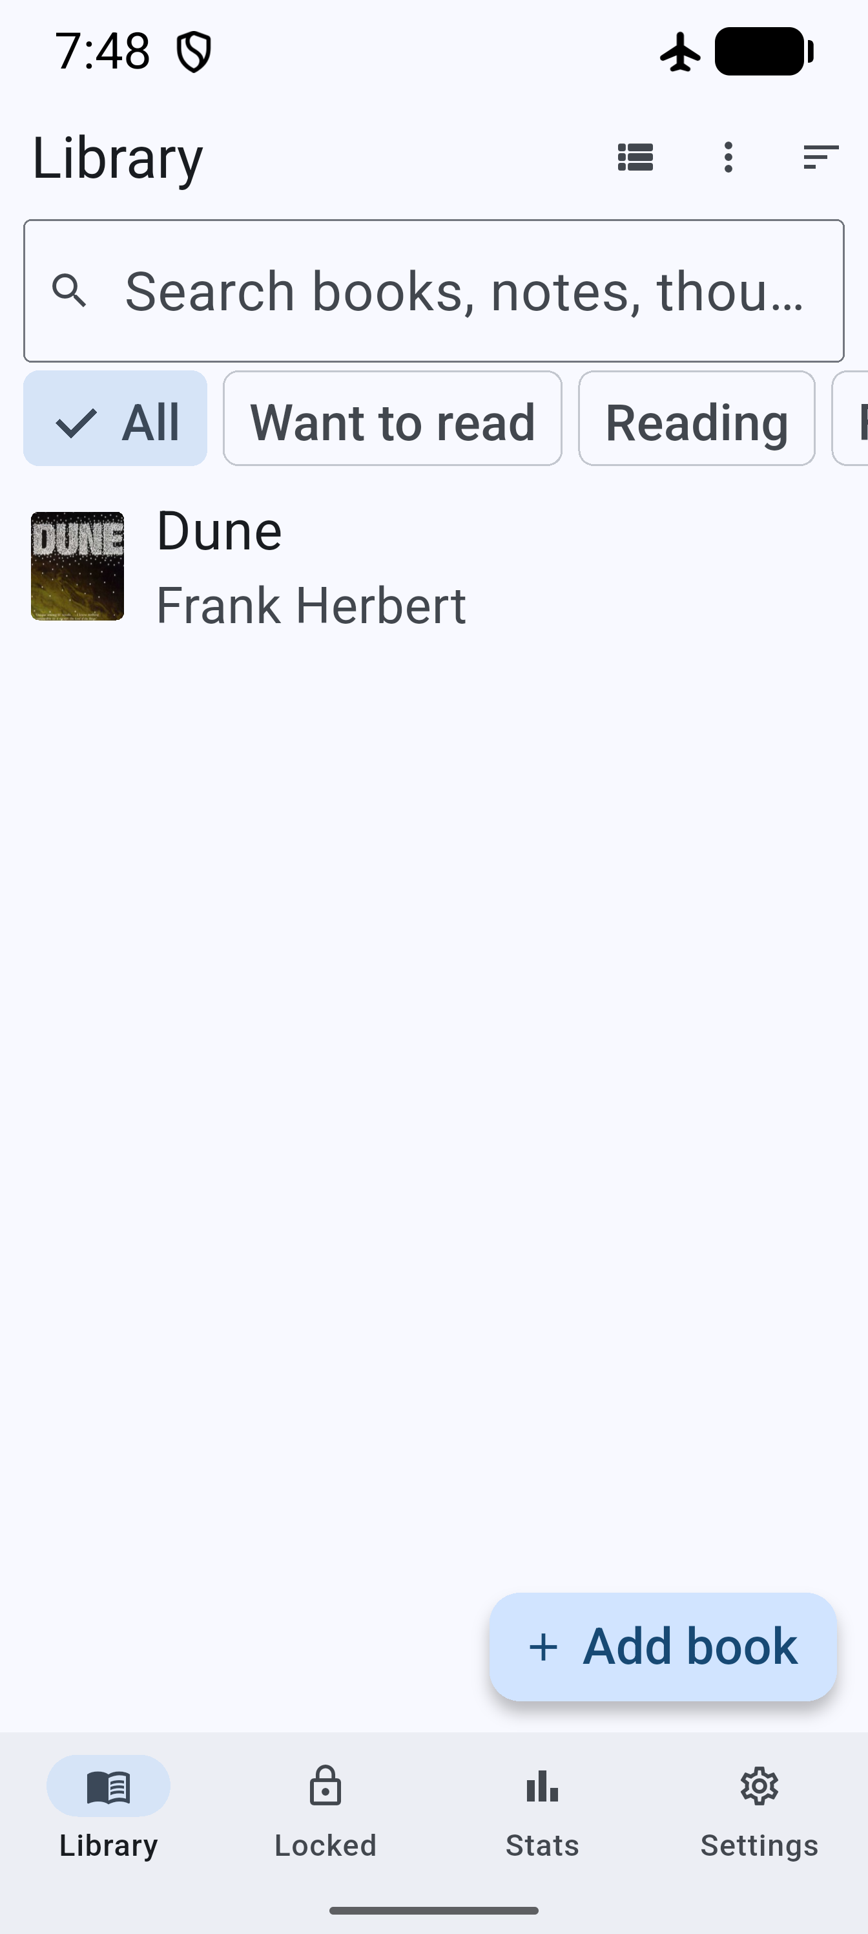
Library at 2.0 font scale, airplane mode on
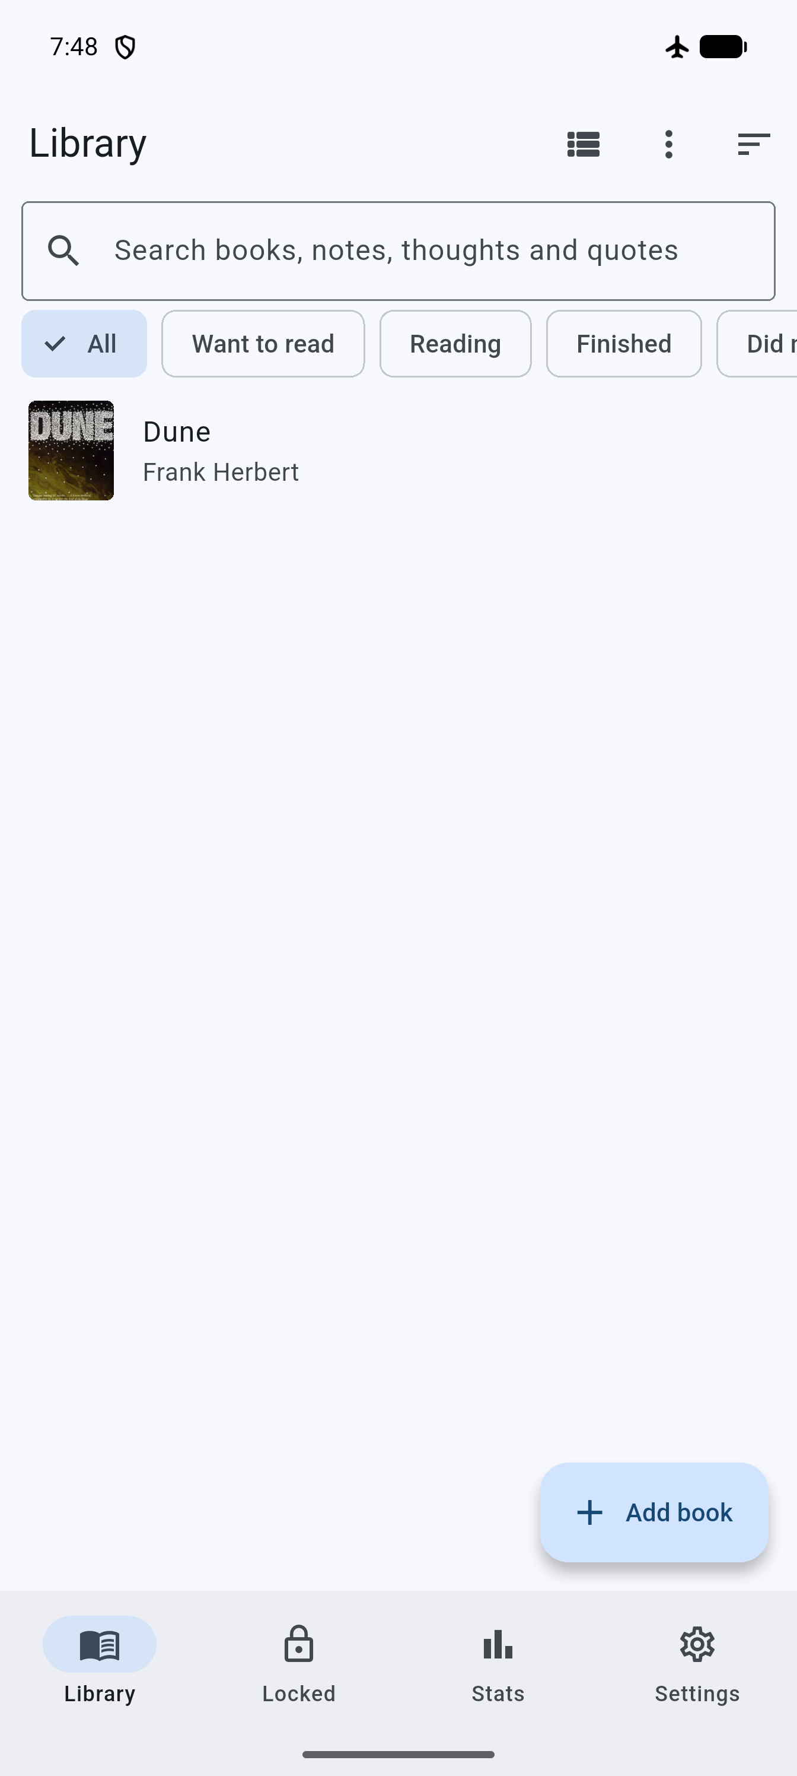
Library launched in airplane mode

Test suite tail (flutter test)
00:16 +295 ~1: All tests passed! (295 passed, 1 skipped). flutter analyze: No issues found.

Fix verification (2026-10-14)
Signed release rebuilt with the fixes. apksigner: v2 true, v3 true, same certificate. libsqlite3.so still bundled without sqlite3_flutter_libs. x86_64 release installed over the existing install: library intact, 0 fatal or ANR lines, cold start 683, 729 and 613 ms (native, unlike the translated arm64 numbers above).
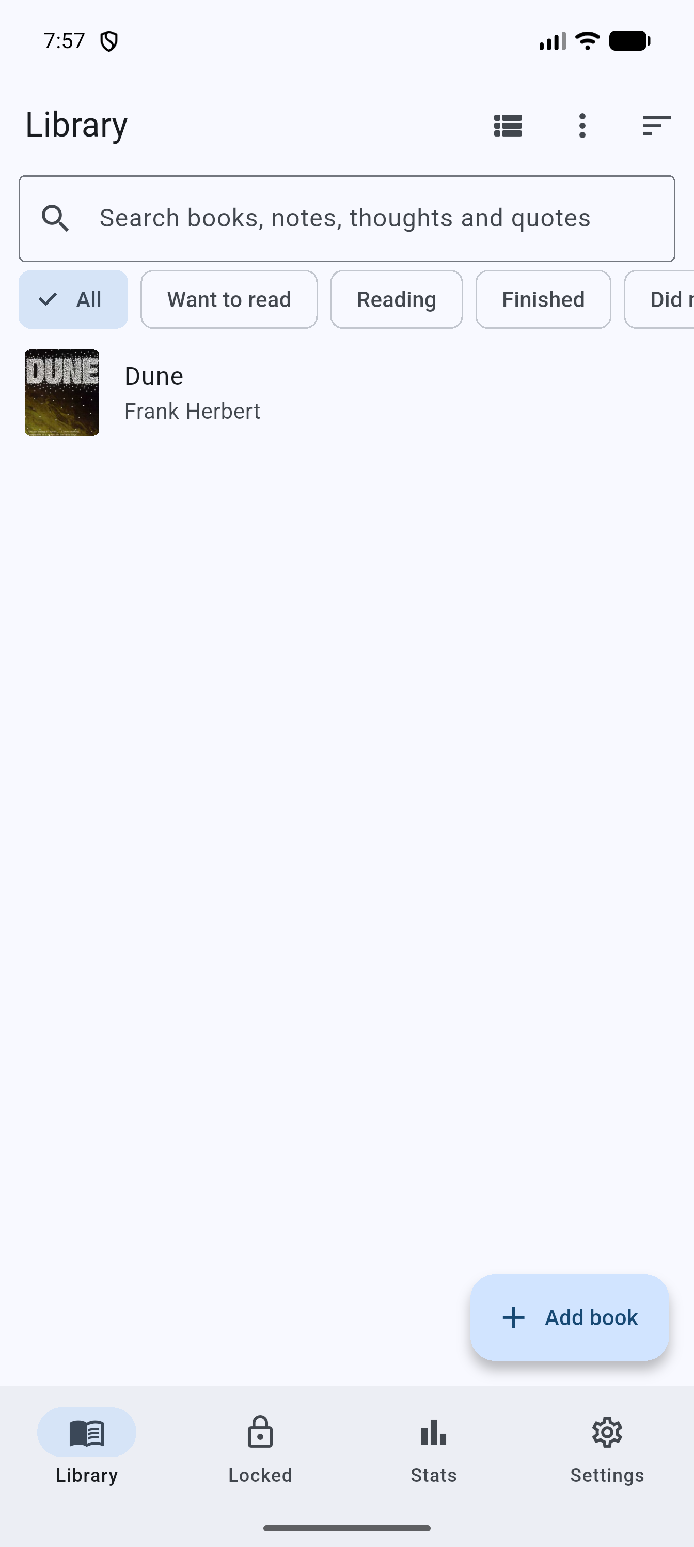
Library after the fixes (x86_64 release build)

